***EXPERIMENT NO : 6***

**Python programs to implement different types of plots using Numpy & Matplotlob.**

***NAME : AKASH RAMKRIT YADAV ID.NO: VU4F2122016***

***BATCH : A BRANCH : IT DIV : A***

***Aim :-***  python programs to implement different types of plots using Numpy

and Matplotlob.

***THEORY:***

***OUTPUT:***

*Python 3.11.0a4 (main, Mar 13 2023, 10:57:32) [MSC v.1929 32 bit (Intel)] on win32*

*Type "help", "copyright", "credits" or "license()" for more information.*

*#AKASH YADAV ID.NO:VU4F2122016 EXP:6 DATE:6/4/2023*

**Matplotlib:**

Matplotlib is a low level graph plotting library in python that serves as a visualization utility.

Matplotlib was created by John D. Hunter.

Matplotlib is open source and we can use it freely.

Matplotlib is mostly written in python, a few segments are written in C, Objective-C and Javascript for Platform compatibility.

**source code for Matplotlib:**

located at this github repository <https://github.com/matplotlib/matplotlib>

## Installation of Matplotlib :

If you have [Python](https://www.w3schools.com/python/default.asp) and [PIP](https://www.w3schools.com/python/python_pip.asp) already installed on a system, then installation of Matplotlib is very easy.

Install it using this command:

**C:\Users*Your Name*>pip install matplotlib**

If this command fails, then use a python distribution that already has Matplotlib installed,  like Anaconda, Spyder etc.

## Import Matplotlib :

Once Matplotlib is installed, import it in your applications by adding the import *module* statement:

import matplotlib

Now Matplotlib is imported and ready to use:

## Checking Matplotlib Version :

The version string is stored under __version__ attribute.

**Example:**

### import matplotlib print(matplotlib.__version__)

# **1]Matplotlib Pyplot :**

**Pyplot**

Most of the Matplotlib utilities lies under the pyplot submodule, and are usually imported under the plt alias:

import matplotlib.pyplot as plt

Now the Pyplot package can be referred to as plt.

## Plotting x and y points

The plot() function is used to draw points (markers) in a diagram.

By default, the plot() function draws a line from point to point.

The function takes parameters for specifying points in the diagram.

Parameter 1 is an array containing the points on the **x-axis**.

Parameter 2 is an array containing the points on the **y-axis**.

## Plotting Without Line

To plot only the markers, you can use shortcut string notation parameter 'o', which means 'rings'.

## Multiple Points

You can plot as many points as you like, just make sure you have the same number of points in both axis.

## Default X-Points

If we do not specify the points on the x-axis, they will get the default values 0, 1, 2, 3 (etc., depending on the length of the y-points.

So, if we take the same example as above, and leave out the x-points, the diagram will look like this:

## Markers

You can use the keyword argument marker to emphasize each point with a specified marker:

Marker Reference

You can choose any of these markers:

Marker Description Marker Description

'o' Circle '1' Tri Down

'*' Star '2' Tri Up

'.' Point '3' Tri Left

',' Pixel '4' Tri Right

'x' X '|' Vline

'X' X (filled) '_' Hline

'+' Plus '>' Triangle Right

'P' Plus (filled)

's' Square

'D' Diamond

'd' Diamond (thin)

'p' Pentagon

'H' Hexagon

'h' Hexagon

'v' Triangle Down

'^' Triangle Up

'<' Triangle Left

**Format Strings fmt**

You can use also use the *shortcut string notation* parameter to specify the marker.

This parameter is also called fmt, and is written with this syntax:

*marker*|*line*|*color*

The marker value can be anything from the Marker Reference above.

The line value can be one of the following:

Line Reference

Line Syntax Description

'-' Solid line

':' Dotted line

'--' Dashed line

'-.' Dashed/dotted line

Note: If you leave out the line value in the fmt parameter, no line will be plotted.

## Marker Size

You can use the keyword argument markersize or the shorter version, ms to set the size of the markers:

## Marker Color

You can use the keyword argument markeredgecolor or the shorter mec to set the color of the edge of the markers:

You can use the keyword argument markerfacecolor or the shorter mfc to set the color inside the edge of the markers:

Use both the mec and mfc arguments to color the entire marker:

# **Matplotlib Line**

## Linestyle

You can use the keyword argument linestyle, or shorter ls, to change the style of the plotted line

Use a dashed line:

plt.plot(ypoints, linestyle = 'dashed')

## Shorter Syntax

The line style can be written in a shorter syntax:

linestyle can be written as ls.

dotted can be written as :.

dashed can be written as --.

**Line Styles**

You can choose any of these styles:

Style Or

'solid' (default) '-'

'dotted' ':'

'dashed' '--'

'dashdot' '-.'

'None' '' or ' '

## Line Color

You can use the keyword argument color or the shorter c to set the color of the line:

## Line Width

You can use the keyword argument linewidth or the shorter lw to change the width of the line.

The value is a floating number, in points:

## Multiple Lines

You can plot as many lines as you like by simply adding more plt.plot() functions:

# **Matplotlib Labels and Title**

## Create Labels for a Plot

With Pyplot, you can use the xlabel() and ylabel() functions to set a label for the x- and y-axis.

## Create a Title for a Plot

With Pyplot, you can use the title() function to set a title for the plot.

## Set Font Properties for Title and Labels

You can use the fontdict parameter in xlabel(), ylabel(), and title() to set font properties for the title and labels.

## Position the Title

You can use the loc parameter in title() to position the title.

Legal values are: 'left', 'right', and 'center'. Default value is 'center'.

# **Matplotlib Adding Grid Lines**

## Add Grid Lines to a Plot

With Pyplot, you can use the grid() function to add grid lines to the plot.

## Specify Which Grid Lines to Display

You can use the axis parameter in the grid() function to specify which grid lines to display.

Legal values are: 'x', 'y', and 'both'. Default value is 'both'

## Set Line Properties for the Grid

You can also set the line properties of the grid, like this: grid(color = 'color', linestyle = 'linestyle', linewidth = number).

# **Matplotlib Subplot**

## Display Multiple Plots

With the subplot() function you can draw multiple plots in one figure:

**CODE :**

import matplotlib.pyplot as plt

import numpy as np

x = np.array(["CNND\n MS.SEEMA LADHE","AT\n MR.NILESH MAIL","MATHS\n MS.DAIMI MARIYA","COA \n MS.NEETA INGLE","OS\n MR.PRAVIN PATIL"])

y = np.array([75, 79,70,68,65])

plt.bar(x, y)

plt.bar(x, y, color = "#4CAF50",width = 0.3)

plt.ylabel("MARKS SCORE")

plt.xlabel("\n SUBJECTS TEACHER")

plt.grid(color = 'green', linestyle = '--', linewidth = 0.5)

plt.show()

**OUTPUT:**

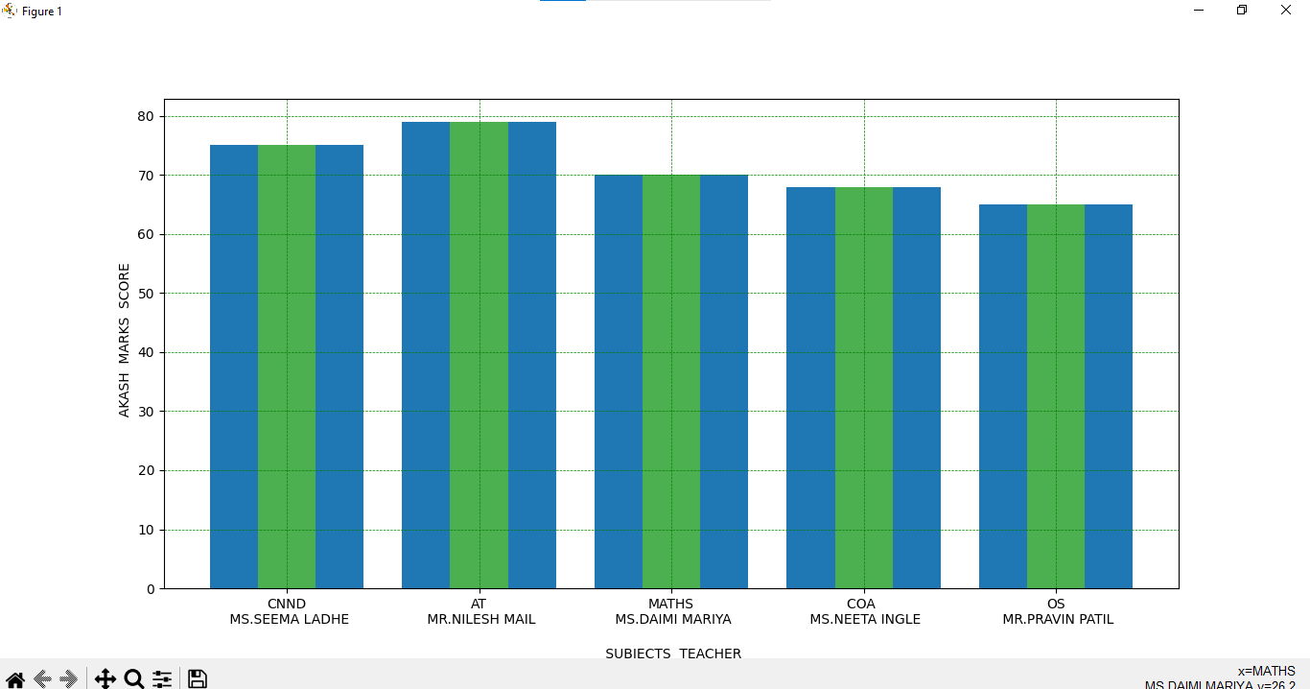

**CODE:**

import matplotlib.pyplot as plt

import numpy as np

xpoints = np.array([0, 2, 4, 0,4,4,4,4,8,4,4,9,9,9,12,9,9,0,12])

ypoints = np.array([0, 8, 0, 4,4,0,8,4,8,8,4,0,8,4,8,4,0,0,0])

plt.plot(xpoints, ypoints)

plt.ylabel("AKASH.R.YADAV")

plt.xlabel("AKASH.R.YADAV== ARY")

plt.show()

**OUTPUT:**

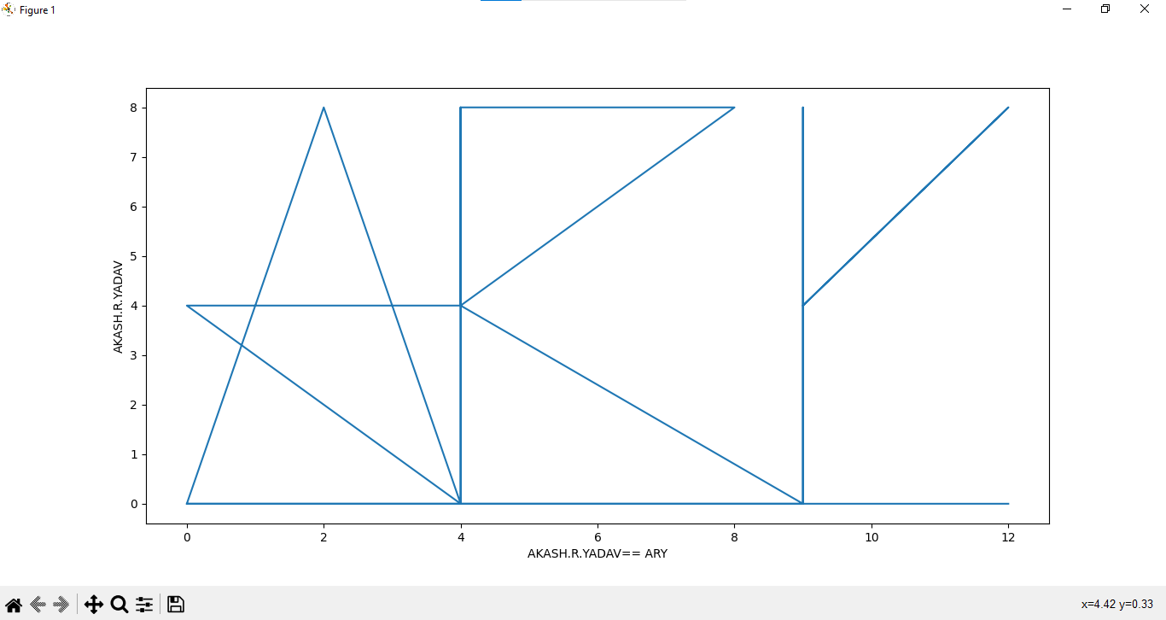

2]Creating Pie Charts :

With Pyplot, you can use the pie() function to draw pie charts:

## By default the plotting of the first wedge starts from the x-axis and moves counterclockwise:

**Note:** The size of each wedge is determined by comparing the value with all the other values, by using this formula:

The value divided by the sum of all values: x/sum(x)

## Labels :

Add labels to the pie chart with the label parameter.

The label parameter must be an array with one label for each wedge:

## Start Angle :

As mentioned the default start angle is at the x-axis, but you can change the start angle by specifying a startangle parameter.

The startangle parameter is defined with an angle in degrees, default angle is 0:

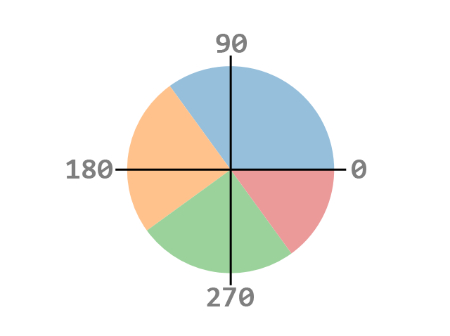

## Explode :

Maybe you want one of the wedges to stand out? The explode parameter allows you to do that.

The explode parameter, if specified, and not None, must be an array with one value for each wedge.

Each value represents how far from the center each wedge is displayed:

## Shadow :

Add a shadow to the pie chart by setting the shadows parameter to True:

## Colors :

You can set the color of each wedge with the colors parameter.

The colors parameter, if specified, must be an array with one value for each wedge:

You can use [Hexadecimal color values](https://www.w3schools.com/colors/colors_hexadecimal.asp), any of the [140 supported color names](https://www.w3schools.com/colors/colors_names.asp), or one of these shortcuts:

'r' - Red  
'g' - Green  
'b' - Blue  
'c' - Cyan  
'm' - Magenta  
'y' - Yellow  
'k' - Black  
'w' - White

**Legend :**

To add a list of explanation for each wedge, use the legend() function:

### **Legend With Header**

To add a header to the legend, add the title parameter to the legend function.

**Code:**

import matplotlib.pyplot as ary

import numpy as a1

y=a1.array([75, 79,70,68,65])

mylabels = ["CNND\n MS.SEEMA LADHE","AT\n MR.NILESH MAIL","MATHS\n MS.DAIMI MARIYA","COA \n MS.NEETA INGLE","OS\n MR.PRAVIN PATIL"]

mycolors = [ "hotpink","r", "b", "#4CAF50","orange"]

myexplode = [0, 0.4, 0, 0,0]

ary.pie(y, labels = mylabels,autopct='%1.2f%%',colors = mycolors, explode = myexplode, shadow = True,startangle = -90)

ary.legend(title = " % of AKASH YADAV \n in TOTAL five subjects:")

#ary.pie(y, labels = mylabels,autopct='%1.2f%%')

ary.show()

**OUTPUT:**

